Project Design Phase
Solution Architecture

Date | 22 July 2026
Team ID | TEAM-HT-2026
Project Name | Heritage Treasures: An In-Depth Analysis of UNESCO World Heritage Sites in Tableau
Maximum Marks | 4 Marks

Solution Architecture:
Solution architecture is a complex process – with many sub-processes – that bridges the gap between business problems and technology solutions. Its goals are to:
- Find the best tech solution to solve existing business problems.
- Describe the structure, characteristics, behavior, and other aspects of the software to project stakeholders.
- Define features, development phases, and solution requirements.
- Provide specifications according to which the solution is defined, managed, and delivered.

Example - Solution Architecture Diagram:


Figure 1: Architecture and data flow of the voice patient diary sample application
Reference: https://aws.amazon.com/blogs/industries/voice-applications-in-clinical-research-powered-by-ai-on-aws-part-1-architecture-and-design-considerations/

Our Solution Architecture – Heritage Treasures Project
The architecture below is organized into three layers: a Data Layer holding the raw UNESCO dataset, a Processing Layer that cleans the data and builds the Tableau visualizations, and a Presentation/Delivery Layer that publishes the workbook and embeds it in a Flask web app for end users.
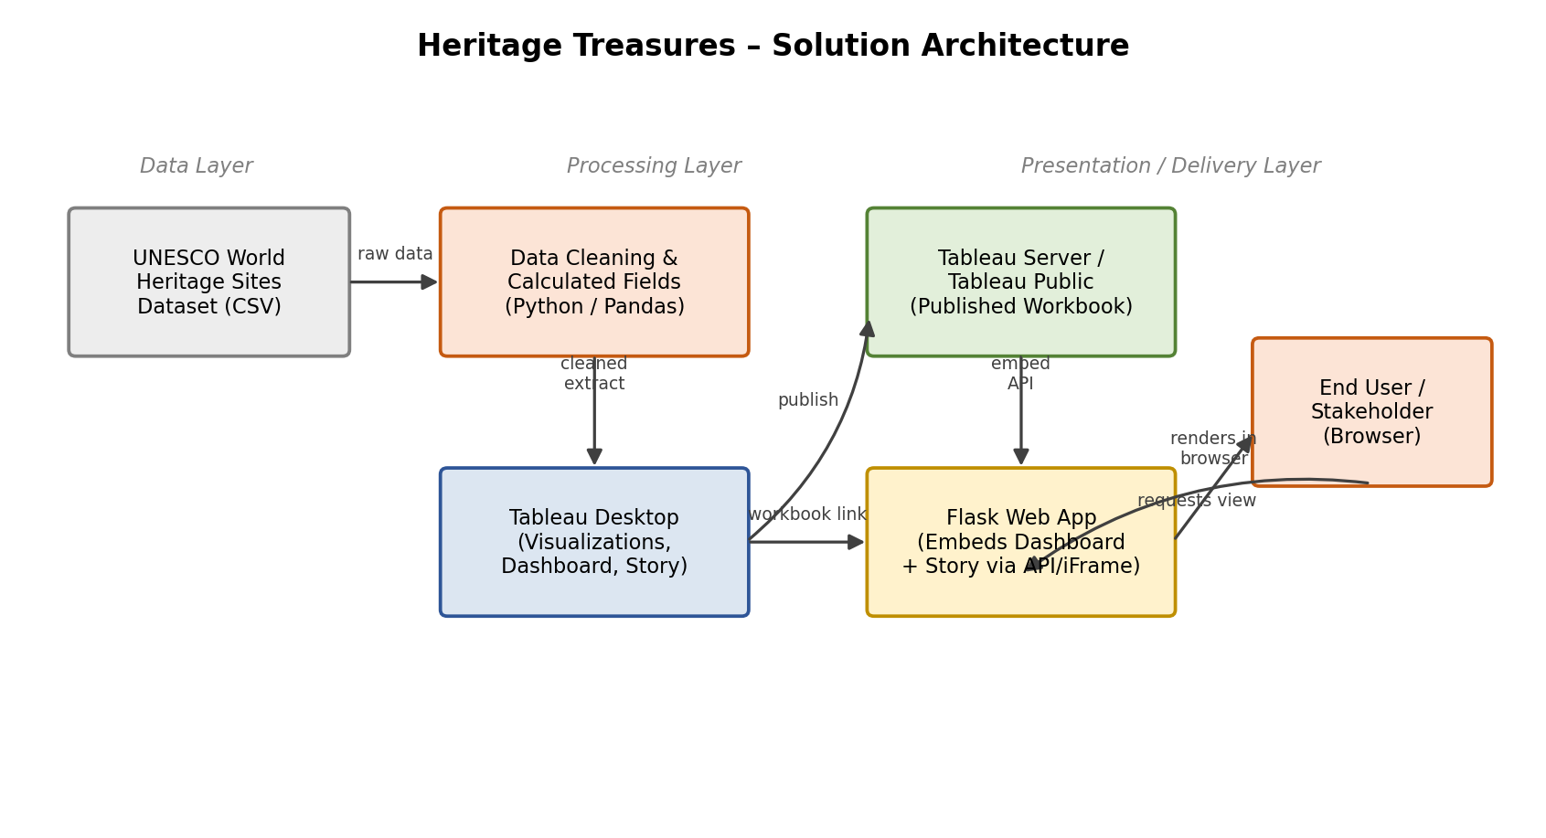

Architecture Components
Layer | Component | Role
Data Layer | UNESCO World Heritage Sites dataset (CSV) | Source of truth: Country, Name_en, Region, Danger, Date_inscribed and other attributes
Processing Layer | Python / Pandas cleaning script | Removes nulls/duplicates, standardizes names, prepares the file for Tableau
Processing Layer | Tableau Desktop | Builds calculated fields, the three core visualizations, dashboard and story
Presentation Layer | Tableau Server / Tableau Public | Hosts the published workbook and serves it via an embeddable link/API
Presentation Layer | Flask Web App | Embeds the dashboard/story into a branded web page and routes user requests
Presentation Layer | End User Browser | Displays the interactive dashboard/story to analysts, policy makers and researchers

